Exercise 1:
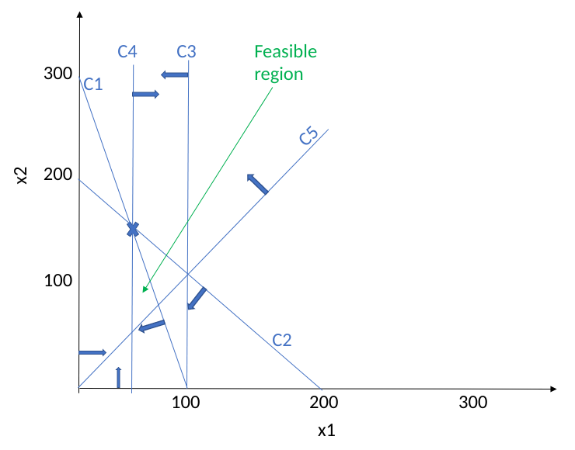
Refer to the figure above for a graphical representation of the problem.
Q1:
- Graphical solution method: Corner points (50,50), (75,75), (50,150)
- Optimum solutions: (75,75) and (50,150). Both yield a profit of $3,000.
Q2:
- The constraint X1 ≤ 100 is redundant since 3X1 + X2 ≤ 300 also means that X1 cannot exceed 100.
- The constraint X1 + X2 ≤ 200 is redundant as well (from graphical method).

